**INSURANCE DATABASE**

show databases;

create database swati;

use swati;

create table persons

(

driver_id varchar(10),

name varchar(20),

address varchar(30),

primary key(driver_id)

);

create table cars (

reg_num varchar(10),

model varchar(10),

year int, primary key(reg_num));

create table accidents(

report_num int,

accident_date date,

location varchar(20),

primary key(report_num));

create table own

(

driver_id varchar(10),

reg_num varchar(10),

primary key(driver_id, reg_num),

foreign key(driver_id) references persons(driver_id),

foreign key(reg_num) references cars(reg_num)

);

create table participateds

(

driver_id varchar(10), reg_num varchar(10),

report_num int, damage_amount int,

primary key(driver_id, reg_num, report_num),

foreign key(driver_id) references persons(driver_id),

foreign key(reg_num) references cars(reg_num),

foreign key(report_num) references accidents(report_num)

);

INSERT INTO persons(driver_id, name, address) VALUES

('A01', 'Richard', 'Shrinivas Nagar'),

('A02', 'Pradeep', 'Rajaji Nagar'),

('A03', 'Smith', 'Ashok Nagar'),

('A04', 'Venu', 'N R Colony'),

('A05', 'John', 'Hanumanth Nagar');

insert into cars(reg_num, model, year) values

('KA052250', "Indica", 1990) ,

('KA031181', "Lancer", 1957),

('KA095477', 'Toyata', 1998),

('KA053408', 'Honda', 2008),

('KA041702', 'Audi' , 2005);

insert into own values

('A01', 'KA052250'),

('A02', 'KA053408'),

('A03', 'KA031181'),

('A04', 'KA095477'),

('A05', 'KA041702');

insert into accidents values

(11, '2003-02-02', 'Mysore Road'),

(12, '2004-01-21', 'South End Circle'),

(13, '2008-02-17', 'Bull Temple Road'),

(14, '2005-03-04', 'Mysore Road'),

(15, '2001-01-01', 'Kanakpura Road');

insert into participateds values

('A01', 'KA052250', 11, 10000),

('A02', 'KA053408', 12, 50000),

('A03', 'KA095477', 13, 25000),

('A04', 'KA031181', 14, 3000),

('A05', 'KA041702', 15, 5000);

**QUERIES:**

1.

select p.name ,damage_amount

from persons p, participateds part

where p.driver_id=part.driver_id and damage_amount >=25000;

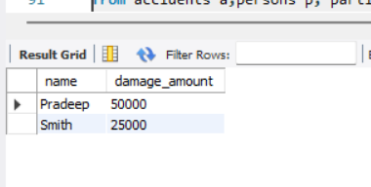

2.

select p.name,c.model

from persons p,cars c, own o

where p.driver_id = o.driver_id and c.reg_num = o.reg_num;

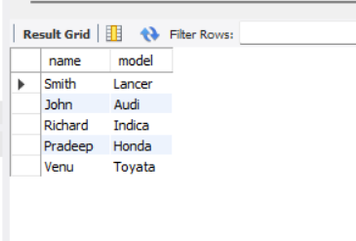

3.

select a.report_num,a.accident_date,a.location,p.name,part.damage_amount

from accidents a,persons p, participateds part

where a.report_num = part.report_num and p.driver_id = part.driver_id;

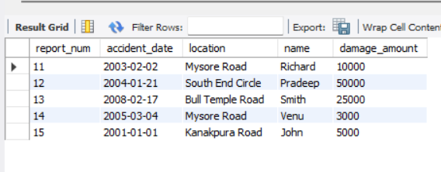

4.

select report_num ,sum(damage_amount)

from participateds

group by report_num;

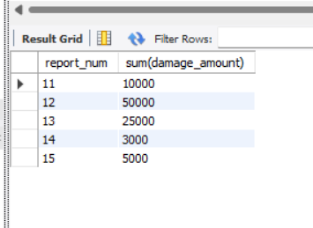

5.

select p.name

from persons p ,accidents a

where (

select count(reg_num)

from participateds d

where d.report_num = a.report_num and p.driver_id = d.driver_id )>1;

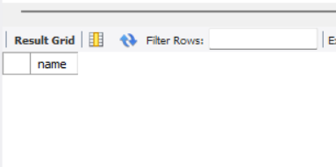

6.

select c.model

from cars c

where reg_num not in (

select reg_num

from participateds d, accidents a

where d.report_num = a.report_num);

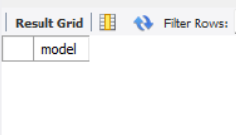

7.

select *

from accidents

order by accident_date desc

limit 1;

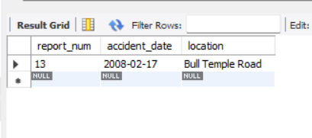

8.

select report_num ,avg(damage_amount)

from participateds

group by report_num;

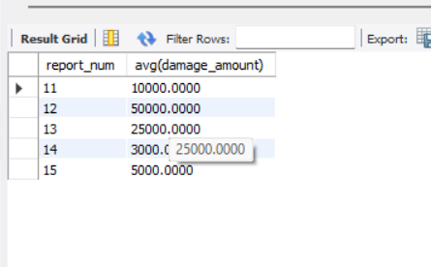

9.

select d.report_num,p.name,d.damage_amount

from persons p ,participateds d

where damage_amount = (

select max(damage_amount)

from participateds

);

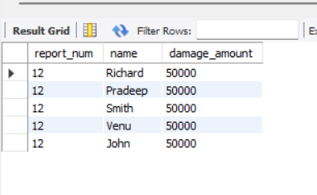

10.

select p.driver_id,p.name

from persons p

where p.driver_id in (

select driver_id

from participateds

where damage_amount = (select max(damage_amount) from participateds)

);

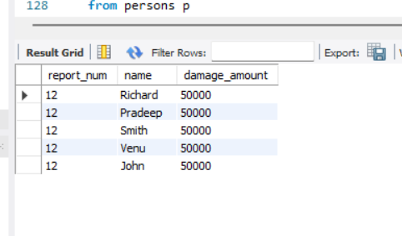

11.

select c.reg_num,c.model

from cars c,accidents a

where reg_num in (

select d.reg_num

from participateds d

where d.report_num = a.report_num and d.damage_amount>20000

);

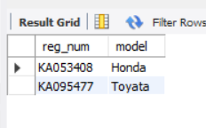

12.

CREATE VIEW accident_summary AS

SELECT

a.report_num,

a.accident_date,

a.location,

COUNT(p.driver_id) AS participant_count,

SUM(p.damage_amount) AS total_damage

FROM

accidents a

LEFT JOIN

participateds p ON a.report_num = p.report_num

GROUP BY

a.report_num, a.accident_date, a.location;

select *

from accident_summary

